BMS INSTITUTE OF TECHNOLOGY
DEPARTMENT OF COMPUTER SCIENCE AND ENGINEERING
DODDABALLAPUR MAIN ROAD, BANGALORE-560 064


A Mini Project Report on

“Graphical implementation ”

Submitted in partial fulfillment of the requirements for the award of the degree of
Bachelor of Engineering in

COMPUTER SCIENCE & ENGINEERING

Submitted By:

Nitesh A Jain Parthsarathy M Alwar
1BY10CS047 1BY08CS049

Under the guidance of:
Mrs. Ambika Mr. Muneshwara. M. S
Asst. Professor, Dept. of CSE Lecturer, Dept. of CSE

YEAR: 2012 - 2013



Department of Computer Science and Engineering

This is to certify that , USN 1BY010CS0 , has successfully completed the mini project entitled “Graphical implementation of ” in partial fulfillment for the award of Bachelor of Engineering in Computer science and Engineering of the Visvesvaraiah Technological University, Belgaum during the year 2010-2011. The project report has been approved as it satisfies the academic requirements in respect of project work prescribed for the Bachelor of Engineering degree.

……………………….. …………………….. …………………….
Signature of the Guide Signature of the Guide Signature of the HOD
Mrs. Ambika Mr. Muneshwara.M.S Mr. Anil .G.N
HOD,Dept.of CSE

Signature of the examiners

_____________________ _____________________
Internal External

ACKNOWLEDGEMENT

The satisfaction and euphoria that accompany the successful completion of any task would be incomplete without the mention of the people who made it possible, whose constant guidance and encouragement crowned our effort with success.

I express my sincere gratitude to our Principal Dr. S. Venkateshwaran, BMS Institute of Technology for providing facilities.

I wish to place on record my grateful thanks to Mr. Anil .G .N, Asst. professor and Head of the Department, Computer Science and Engineering, BMS Institute of Technology, Bangalore for providing the encouragement and guidance.

I hereby like to thank Mrs. Ambika and Mr. Muneshwara M S on their periodic inspection, time to time evaluation of the project and help to bring the project to the present form.

Also I would like to thank the members of the faculty of CS&E department whose suggestions enabled me to surpass many of the seemingly impossible hurdles.

Finally, I thank my parents who have given me financial and spiritual support. Thank you for all my friends and classmates who have given comments and supports throughout the project.

ABSTRACT

CONTENTS

Acknowledgement ……………………………………………………………. i
Abstract ……………………………………………………………………….. ii
Contents ………………………………………………………………………. iv
- Introduction ……………………………………………………………. 1
  - Computer Graphics ………………………………………………....1
  - Image Types …………………………………………………………2
  - OpenGL………………………………………………………………4

- Requirements…………………………………………………………….9
  - Software Requirements ……………………………………………...9
  - Hardware Requirements ……………………………………………..9

- Design …………………………………………………………………..10

- Implementation …………………………………………………………11
  - Introduction ………………………………………………………….11
  - Inbuilt Functions …………………………………………………….12
  - User defined Functions ……………………………………………...16

- Screenshots ..............................................................................................18

- Conclusion ...............................................................................................21

Bibliography
Chapter1.
Introduction

  - COMPUTER GRAPHICS
Today, computers and computer-generated images touch many aspects of daily life. Computer imagery is found on television, in newspapers, for example in weather reports, or for example in all kinds of medical investigation and surgical procedures. A well-constructed graph can present complex statistics in a form that is easier to understand and interpret. In the media "such graphs are used to illustrate papers, reports, theses", and other presentation material.
Many powerful tools have been developed to visualize data. Computer generated imagery can be categorized into several different types: 2D, 3D, 5D, and animated graphics. As technology has improved, 3D computer graphics have become more common, but 2D computer graphics are still widely used. Computer graphics has emerged as a sub-field of computer science which studies methods for digitally synthesizing and manipulating visual content. Over the past decade, other specialized fields have been developed like information visualization, and scientific visualization more concerned with "the visualization of three dimensional phenomena (architectural, meteorological, medical, biological, etc.), where the emphasis is on realistic renderings of volumes, surfaces, illumination sources, and so forth, perhaps with a dynamic (time) component".
HISTORY
The advance in computer graphics was to come from one MIT student, Ivan Sutherland. In 1961 Sutherland created another computer drawing program called Sketchpad. Using a light pen, Sketchpad allowed one to draw simple shapes on the computer screen, save them and even recall them later.
The first major advance in 3D computer graphics was created at UU by these early pioneers, the hidden-surface algorithm. In order to draw a representation of a 3D object on the screen, the computer must determine which surfaces are "behind" the object from the viewer's perspective, and thus should be "hidden" when the computer creates (or renders) the image.

  - IMAGE TYPES
2D computer graphics:
2D computer graphics are the computer-based generation of digital images—mostly from two-dimensional models, such as 2D geometric models, text, and digital images, and by techniques specific to them.2D computer graphics are mainly used in applications that were originally developed upon traditional printing and drawing technologies, such as typography, cartography, technical drawing, and advertising. Two-dimensional models are preferred, because they give more direct control of the image than 3D computer graphics, whose approach is more akin to photography than to typography.
There are two approaches to 2D graphics: vector and raster graphics.
- Pixel art: Pixel art is a form of digital art, created through the use of raster graphics software, where images are edited on the pixel level.
- Vector graphics: Vector graphics formats are complementary to raster graphics, which is the representation of images as an array of pixels, as it is typically used for the representation of photographic images.
3D computer graphics:
With the birth of the workstation computers(like LISP machines, paintbox computers and Silicon Graphics workstations)came the 3D computer graphics.3D computer graphics in contrast to 2D computer graphics are graphics that use a three-dimensional representation of geometric data that is stored in the computer for the purposes of performing calculations and rendering 2D images.
Some major advances in 3D computer graphics since then have been:
- Flat shading: A technique that shades each polygon of an object based on the polygon's "normal" and the position and intensity of a light source.
- Gouraud shading: Invented by Henri Gouraud in 1971, a fast and resource-conscious technique used to simulate smoothly shaded surfaces by interpolating vertex colors across a polygon's surface.
- Texture mapping: A technique for simulating surface detail by mapping images (textures) onto polygons.
- Phong shading: Invented by Bui Toc Phong, a smooth shading technique that approximates curved-surface lighting by interpolating the vertex normals of a polygon across the surface; the lighting model includes glossy reflection with a controllable level of gloss.
- Bump mapping: Invented by Jim Blinn, a normal-perturbation technique used to simulate bumpy or wrinkled surfaces.
- Raytracing: A method based on the physical principles of geometric optics that can simulate multiple reflections and transparency.
- Radiosity: a technique for global illumination that uses radiative transfer theory to simulate indirect (reflected) illumination.
APPLICATIONS OF COMPUTER GRAPHICS
- Computational biology
- Computational physics
- Computer-aided design
- Computer simulation
- Digital art
- Education
- Graphic design
- Video Games
- Virtual reality
- Web design

  - OPENGL

As a software interface for graphics hardware, OpenGL's main purpose is to render two- and three-dimensional objects into a frame buffer. These objects are described as sequences of vertices (which define geometric objects) or pixels (which define images). OpenGL performs several processing steps on this data to convert it to pixels to form the final desired image in the frame buffer.
- OpenGL Command Format
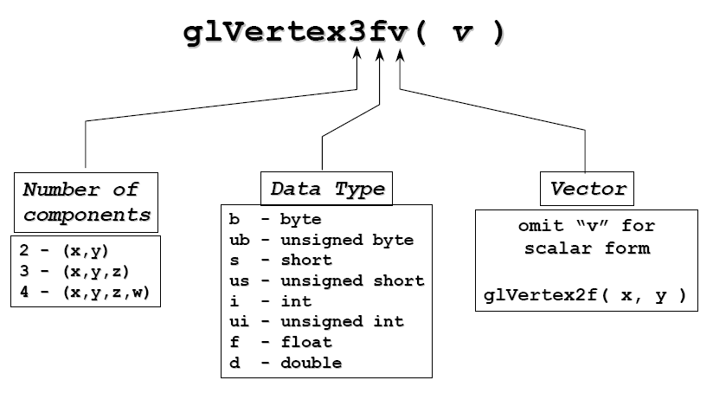
Basic OpenGL Operation
The figure shown below gives an abstract, high-level block diagram of how OpenGL processes data. In the diagram, commands enter from the left and proceed through what can be thought of as a processing pipeline. Some commands specify geometric objects to be drawn, and others control how the objects are handled during the various processing stages.

OpenGL Block Diagram
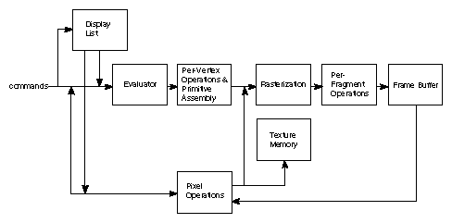

As shown by the first block in the diagram, rather than having all commands proceed immediately through the pipeline, you can choose to accumulate some of them in a display list for processing at a later time.
The evaluator stage of processing provides an efficient means for approximating curve and surface geometry by evaluating polynomial commands of input values. During the next stage, per-vertex operations and primitive assembly, OpenGL processes geometric primitives—points, line segments, and polygons, all of which are described by vertices. Vertices are transformed and lit, and primitives are clipped to the viewport in preparation for the next stage.
Rasterization produces a series of frame buffer addresses and associated values using a two-dimensional description of a point, line segment, or polygon. Each fragment so produced is fed into the last stage, per-fragment operations, which performs the final operations on the data before it's stored as pixels in the frame buffer. These operations include conditional updates to the frame buffer based on incoming and previously stored z-values (for z-buffering) and blending of incoming pixel colors with stored colors, as well as masking and other logical operations on pixel values.
Input data can be in the form of pixels rather than vertices. Such data, which might describe an image for use in texture mapping, skips the first stage of processing described above and instead is processed as pixels, in the pixel operations stage. The result of this stage is either stored as texture memory, for use in the rasterization stage, or rasterized and the resulting fragments merged into the frame buffer just as if they were generated from geometric data.
All elements of OpenGL state, including the contents of the texture memory and even of the frame buffer, can be obtained by an OpenGL application.

GLUT
GLUT (pronounced like the glut in gluttony) is the OpenGL Utility Toolkit, a window system independent toolkit for writing OpenGL programs. It implements a simple windowing application programming interface (API) for OpenGL. GLUT makes it considerably easier to learn about and explore OpenGL programming. GLUT provides a portable API so you can write a single OpenGL program that works on both Win32 PCs and X11 workstations.
GLUT is designed for constructing small to medium sized OpenGL programs. While GLUT is well-suited to learning OpenGL and developing simple OpenGL applications, GLUT is not a full-featured toolkit so large applications requiring sophisticated user interfaces are better off using native window system toolkits like Motif. GLUT is simple, easy, and small. My intent is to keep GLUT that way.
The GLUT library supports the following functionality:
- Multiple windows for OpenGL rendering.
- Callback driven event processing.
- An `idle' routine and timers.
- Utility routines to generate various solid and wire frame objects.
- Support for bitmap and stroke fonts.
- Miscellaneous window management functions.
OPENGL PRIMITIVES
The programmer is provided the following primitives for use in constructing geometric objects.
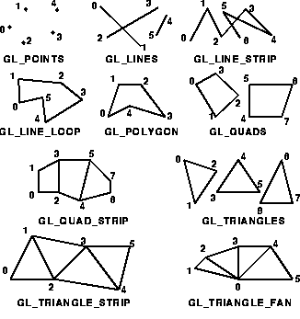

API HIERARCHY
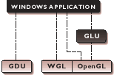
~ OpenGL applications use the window system’s window, input, and even the
mechanism.
~ GLU supports quadrics, NURBS, complex polygons, matrix utilities, and more.

APPLICATIONS OF OPENGL

- Virtual reality
- CAD
- Scientific Visualization
- Information Visualization
- Flight simulation
- Video games, where it competes with Direct3D
- Animations
Interfacing with the User.
Chapter 2.
Requirements

  - Software Requirements:
- Microsoft Windows XP, Windows 7.
- OpenGL runtime libraries – glut, glu and gl.
- Any Compiler like Cygwin, MinGW, UNIX compilers.
- Any IDE (Integrated Development Environment) like Microsoft Visual C++, Netbeans, Eclipse.

  - Hardware Requirements:
- Intel Dual Core Processor or higher.
- 512 MB of RAM for Windows XP and 1 GB RAM for Windows 7.
- Keyboard, Mouse, Monitor.

Chapter 3.
Design
Chpater 3.
Implementation
  - Introduction
The program is implemented using OpenGL library. OpenGL is a software interface to graphics hardware. This interface consists of about 150 distinct commands that you use to specify the objects and operations needed to produce interactive three-dimensional applications. OpenGL is designed as a streamlined, hardware-independent interface to be implemented on many different hardware platforms. To achieve these qualities, no commands for performing windowing tasks or obtaining user input are included in OpenGL; instead, you must work through whatever windowing system controls the particular hardware you're using. Similarly, OpenGL doesn't provide high-level commands for describing models of three-dimensional objects. Such commands might allow you to specify relatively complicated shapes such as automobiles, parts of the body, airplanes, or molecules. With OpenGL, you must build up your desired model from a small set of geometric primitives - points, lines, and polygons sophisticated library that provides these features could certainly be built on top of OpenGL. The OpenGL Utility Library (GLU) provides many of the modeling features, such as quadric surfaces and NURBS curves and surfaces. GLU is a standard part of every OpenGL implementation. Also, there is a higher-level, object-oriented toolkit, Open Inventor, which is built atop OpenGL, and is available separately for many implementations of OpenGL.

  - The inbuilt functions used in the project are as follows:

- void glutInit(int argc, char **argv)
Initializes GLUT. The arguments passed from main can be used by the applicaions.

- void glutInitDisplayMode(unsigned int mode)
Requests a display with properties in mode. The value of the mode is determined by logical OR operaion.
Mode values used are GLUT_DOUBLE, GLUT_RGB, GLUT_DEPTH.

- void glutInitWindowSize(int width, int height)
Specifies the initial width and height of the window in pixels.

- int glutCreateWindow(const char *title)
Gives a name to the window which is created.

- void glutDisplayFunc(void (*func)(void))
Registers the display function ‘func’ that is executed when the window needs to be redrawn.

- void glutMouseFunc(void (*func)(int button, int state, int x, int y))
The callback function returns the button, GLUT_LEFT_BUTTON, GLUT_RIGHT_BUTTON, GLUT_MIDDLE_BUTTON, the state of the button after the event GLUT_UP or GLUT_DOWN and the position of the mouse relative to the top corner of the window.

- void glutKeyboardFunc(void (*func)(int key, int x, int y))
The callback function returns the key pressed with the coordinates of the mouse relative to the top corner of the window.

- void glutIdleFunc(void (*func)(void))
glutIdleFunc sets the global idle callback to be func so a GLUT program can perform background processing tasks or continuous animation when window system events are not being received. If enabled, the idle callback is continuously called when events are not being received. The callback routine has no parameters. The current window and current menu will not be changed before the idle callback. Programs with multiple windows and/or menus should explicitly set the current window and/or current menu and not rely on its current setting.
The amount of computation and rendering done in an idle callback should be minimized to avoid affecting the program's interactive response. In general, not more than a single frame of rendering should be done in an idle callback.

- void glutReshapeFunc(void (*func)(int width, int height))
glutReshapeFunc sets the reshape callback for the current window. The reshape callback is triggered when a window is reshaped. A reshape callback is also triggered immediately before a window's first display callback after a window is created or whenever an overlay for the window is established. The width andheight parameters of the callback specify the new window size in pixels. Before the callback, the current window is set to the window that has been reshaped.
If a reshape callback is not registered for a window or NULL is passed to glutReshapeFunc (to deregister a previously registered callback), the default reshape callback is used. This default callback will simply call glViewport(0,0,width,height) on the normal plane (and on the overlay if one exists).
If an overlay is established for the window, a single reshape callback is generated. It is the callback's responsibility to update both the normal plane and overlay for the window (changing the layer in use as necessary).
When a top-level window is reshaped, subwindows are not reshaped. It is up to the GLUT program to manage the size and positions of subwindows within a top-level window. Still, reshape callbacks will be triggered for subwindows when their size is changed using glutReshapeWindow.

- void myinit(void)
The initialization function. Usually used to initialize the matrix mode, set the background screen color, setting the clipping volume.
The clipping volume can be either perspective viewing or orthographic viewing.

- glPushMatrix()
Saves the present matrix on the OpenGL stack.

- glPopMatrix()
Restores the previous matrix which was pushed onto the stack.

- glTranslatef(float x, float y, float z)
Translates to the coordinates given by the parameters.
- glRotatef(float theta, float x, float y, float z)
Rotates the object with reference to the origin along the coordinate axes specified by x, y and z.
x = 1 indicates rotate the object along the x-axis and x = 0 indicates do not rotate the object along the x-axis. It also applies to the other axes as well.
The angle of rotation is specified by the first parameter theta.

  - These are the user defined functions used:

Chapter 4.
Screenshots

Chapter 5.
Conclusion

This project successfully builds

Bibliography

Books:
- “Interactive Computer Graphics” by Edward Angel.

Websites:
- www.opengl.org
- www.wikipedia.org

